# The City Lit Institute

##### Department of Computing

## Keeley Street, Holborn, London WC2B 4BA

**MySQL**

**(with Apache server)**

**LECTURER** : **ALEXANDER ADU-SARKODIE**

MSc. Telematics (IT & Telecom), MSc. Eng., Dip. Russ. Lang., Teach. Cert, AMIAEng (UK), MBCS (UK), MIfL(UK)

**Biopic :** [**http://goldhawk-college.com/istudio/**](http://goldhawk-college.com/istudio/)

**Blog :** [**http://www.blogger.com/profile/14800490193632788559**](http://www.blogger.com/profile/14800490193632788559)

**Email :** [**aadusarkodie1@gmail.com**](mailto:aadusarkodie1@gmail.com)

**Importing data into MySQL using phpMyAdmin client**

* First, obtain a database file you want to import or a delimited text file, which is basically a listing of table columns where each column of data is separated by, or marked off by, or **delimited by** a character. Common delimiting characters are the comma, semi-colon and quote marks, but any character may be used as long as you indicate what the delimiters are.
* In phpMyAdmin select your database and table into which you want to import data and click on the Import tab.

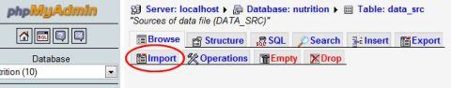

* Browse to the location of your delimited text file and select the character set of the file if the default is not correct.

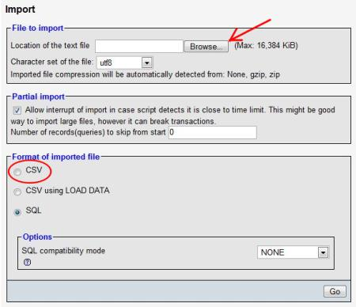

* Under “Format of imported file”, click CSV, which stands for comma separated values file or character separated values file. An options form will open when CSV is chosen, but if SQL is checked the options form remains hidden.

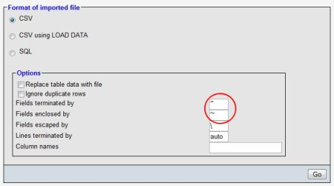

* Under “Options” you can tick off the boxes for ‘Replace table data with file’ and ‘Ignore duplicate rows’ if either function is desired.
* Enter the characters that are appropriate for your CSV under ‘Fields terminated by’ and ‘Fields enclosed by’
* Characters for escaping fields or terminating lines can be input here, too. Also, if you want to add column names enter the names separated by commas in the blank provided. When ready, hit “Go”.
* If successful, you’ll get a message that X number of queries were executed, which means that X number of records were imported into your table. If not successful, check the number of columns and the characters that you’ve input for the CSV and try again.
* Your system may limit the size of file that can be imported.

**Backup your data**

* Click on your database name in the left hand navigation bar
* Click on EXPORT (top tab)
* Highlight the table/s you want to back up
* Select STRUCTURE and DATA radio button
* Select "Enclose table and field names with backquotes"
* Select "Save as file" and "zipped" check boxes
* Click "Go" and a zipped archive file will be generated.
* <https://www.youtube.com/watch?v=diEwQk4uY14>
* <http://stackoverflow.com/questions/23815741/import-csv-file-into-mysql-using-phpmyadmin>